**Index**

|  |  |  |
| --- | --- | --- |
| **Sr. No** | **Name Of Topic** | **Page No.** |
| **1** | Introduction  * Company Profile * Introduction To System |  |
| **2** | **Analysis**   * Fact Finding Techniques * Feasibility Study * Hardware and Software Requirement |  |
| **3** | **System Design**   * ER Diagram * Context Level Diagram * Data Flow Diagram * UML Diagram * Data Dictionary |  |
| **4** | **Form Design**  **[ Input/Output]** |  |
| **5** | **Reports** |  |
| **6** | **Advantages & Limitations** |  |
| **7** | **Conclusion** |  |
| **8** | **Bibliography** |  |

**preface**

Whenever we See various type of Bikes model System related to “**Rajendra Honda Showroom management”** they give us a handmade receipt, maintain model Information on. He may make certain mistakes while generating this receipt. Also if he wants to make report of saleing, it takes much time for calculations may be done wrong.

Taking this point into consideration model information Model is developed. This application is mainly developed for transaction processing of Management System. Its user friendly interface allows user to use this application with ease.

In modern days workload is increase and the need of computerization will be occurred, reduced manual work & accurate. To fulfilling this need we are designing and developing this project with the help of this software maintains the report and the records are easy. The models Information will do throughout this project.

Trying to create project is helpful for increasing efficiency, effectiveness, profitability for Company.

**ACKNOWLADGEMENT**

Before we get into thick of the things We would like to add few heartfelt words for the people who were the part of this project in numerous ways….people who have an ending support right from the stage the basic ideas was conceived.

We begin words of thanks praising the almightily god that is the unseen force in all the activities of my life.

We wish to convey my deep sense of gratitude to my experience and energetic guide.

Prof. Bachchhav s.k For her valuable suggestions and guidance this project report.

We also acknowledge with sense of reverence my gratitude towards the **Prof. Kashid P.R[HOD]** of Dept. of computer Application for providing me an opportunity to work as a trainee in their esteemed organization.

Lastly it would be unjust if we don’t mention my parents and friends without whose support and motivation this project won’t have completed.

## Miss.Nehe Jyoti Govind

Miss.Varpe Aishwarya Subhash

## Introduction

## “Rajendra Honda Showroom Management System”

In this project we are describing the computerize system are use manually in Rajendra Honda showroom management system.As developed in this system which allow the customer to choose there dream bikes. We had studies this system with respect to the **‘Rajendra Honda showroom’situated at Nashik pune highway,sanagamner,Dist.Ahmednagar.**

In this showroom currently transaction with respect to the applicant or people are carried out by manually.Customer can select desired models of bikes & purchase to particular select bikes.In this billing section customer is required to fill up form with her/his details information mentioned in the form.After submitting this ful filled from the customer provide final bill.

So we have stuied this system to remove the problem which are occurred due to manual system.

* Showroom Name:Rajendra Honda Showroom.
* Address:Nashik pune highway ,Sangamner.
* Owner:Omkar somani.
* Models: Bikes.

**FACT FINDING TECHNIQUES**

Preliminary Investigation implies that which methods are applies to make research of company & by which means information is collected regarding product. Generally there are three methods for collecting the information of any instruction.

These are:-

1. Interview
2. Questionnaires
3. Observations

All the methods are equally important. As far as this project is concerned & have to be collected all the information by following methods.

**1) Interview:-**

Interview is nice method to communicate with people. We can understand view, attributes & members to get information about management system & facilities provided to staff & other attendance.

Institute management is the one of the most important factor playing master role in the success of any institute. In manual system it is difficult to find specific candidate’s record in quick time. But by using “**Rajendra Honda Showroom System**” we will find his or her record immediately. Also find the candidates details.

First we visit the “Raj Moll” & asking how they maintain the records.

How many rooms are available in our hotel, which manner they keep records of moll, customer stay details.

The information collected by this manner from various categories that are related to the system.

**2) Questionnaires:-**

I have asked following questions:-

* Type what of problem are occurs in existing system?
* What type of system is used to collect the data?
* Is there any facility of taking record of shop and customers?
* How to update shop status?
* How to maintain customer stay records?
* How you maintain privacy?
* How to prepare a bill

**3) Observations:-**

This method is very lengthy. I also observed that there are more chances of mistakes because of manual process. This process is time consuming.

In this technique information collected through observation of the hotel. In this method we observe flow of document, way the process is carried out step followed the person involved, etc.

We find entity needed for the system & develop the system using this feasibility study & fact finding technique.

**Feasibility Study**

provide you the proper information and easy operation the crucial part is deciding upon the user requirement and to provide him /her the best possible solution .investigating the need for the system generating new ideas about functionality of the system yield best output as we know creativity is essential to innovation .thus the objective of the feasibility study may be viewed as

1. The system should meet the user needs.

2. The system should be economical

3. Crucial part from user /client point of view is that he/she should be able to operate the system easily and efficiently.

4. The system can be easily operated.

The system should The success of any system resides particularly from the user point is that, does the system be easily maintained and enhanced.

From above point of views, we came to conclusion that “feasibility study” is conducted to test the operational, economical and technical feasibility of the system.

Thus the feasibility of the system can be viewed from following three angles:-

**1)** **Technical feasibility-**

Technical feasibility is mainly concerned with whether the system proposed for development can be computerized .this needs to consider the possibilities of using machines available. If the hardware is being used in the system .it is always desirable to select the best package that will be easy to implement for the system designing and a interactive a possible to user.

**2) Operational feasibility:**

The system is user friendly and it is easily accessible its users. Operational feasibility is mainly concerned with whether the system is user friendly, In this system.

We have followed a menu driven architecture as we see in the internet sites ,which is user friendly .it is much easier to operate ,interface of the system and form are maintained properly so that user can handle easily.

**3) Economical feasibility:**

Cost of development of the project is analyzed by manpower used to build the system(e.g coding testing debugging etc.) and the efficiency, correctness user satisfaction .all the above points yield the cost of the project.

**REQUIREMENT ANALYSIS**

**Under our project resources are categorized in two main types:-**

* **Hardware Resources.**
* **Software Resource**

**Hardware Resources and specification**:-

* The minimum requirement of hardware for our system are:-
  + Processor : Pentium or above.
  + RAM : 2 GB or above.
  + Monitor : CRT or LCD Monitor.
  + Hard Disk : 500GB or Above

**Software Resources and specification:-**

* + Operating System : Windows 7
  + Development Tool : Jdk 1. 8.0
  + Database : Ms Access
  + Documentation tool : MS-Word.

**ER-Diagram**

**Common Diagram Containing Following**

|  |  |  |
| --- | --- | --- |
| **Symbol Name** | **Description** | **Symbol** |
| Rectangle | This represented an entity set |  |
| Diamond | Used to represent relationship sets |  |
| Ellipse | Used to represent Attributes |  |

An entity relationship analysis, system analyst has to find out all possible entities which play a role in system and which can be properly defined in system. All distinguish attributes, which are associated which an entity must be identified. After identified entities and attributes the relation between entities can be found.

givesto

quotation

Document

customer

visit

generate

validate

Hondashowroom

workin

Employee

maintain

check

bikes

stock

check

paid

generate

Bill

**2. DATA FLOW DIAGRAM**

Data flow diagram is used to represent data & processes that manipulate it. The data flow diagram enables the software engineer to develop the model of information domain & functional domain at same time. As the DFD is refined into greater levels of details, the analyst performs implicit functional decomposition of the system.

A data flow Diagram (DFD) is one of the popular graphical tool uses to depict the flow of data through a system. DFD shows the processes, data stores, data flow & the source & destination entries.

A few simple guidelines can aid immeasurably during derivation of data flow diagram.

1. The level 0 DFD should depict the system as a single bubble.

2. The primary input & output should be carefully noted.

3. Refinement should being by isolating candidate processes, data object &

Stores to be represented at the next level.

4. All arrows & bubbles should be labeled with meaningful names.

5. Information flow continuity must be maintained from level to level.

One bubble at time should be refined.

**TYPES OF DFD’S**

There are two types of DFD’S as follows:-

**1) Physical DFD’S:-**

Physical DFD’S depict the physical elements like people, report, documents, departments etc. Physical DFD’S shows an implementation dependent view of the system.

**2) Logical DFD’S:-**

Logical DFD’S depict the logical elements like data process & events those are abstract than physical DFD’S. Logical DFD’S shows an implementation independent view of the system

CONTEXT LEVEL DFD

Submit details store details

Retrieve detail

Customer-db

customer

Show detail

Submit details store details

Employee-db

employee

Show details retrieve details

Submit detail store details

Qutation-db

Quotation

Show details retrieve details

Submit details store details

Bikes-db

bikes

Show details retrieve details

Store details

Submit details

Document-db

document

Show detail

Retrieve details

Store detail

Submit detail

Stock-db

stock

Show detail

Retrieve detail

Store detail

Submit detail

Retrieve detail

Bill-db

bill

Show detail



*Submit details store details*

Bill

*Bill_db*

*Show details retrieve details*

*Submit details store details*

report

*Report_db*

*Show details retrieve details*

* **Customer:-**

Submit details

**Second level DFD**

Cust_no

Show details

Submit details

Cust_name

Show details

submit details

Show details

Cust_add

Show details

submit details

username

Show details

Submit details

password

customer_db

* **Employee:-**

Submit details

emp_no

Show details

Submit details

emp_name

Show details

Submit details

emp_add

Show details

Submit details

username

Show details

Submit details

password

Show details

Employee_db

* **Bill:-**

Submit details

b_no

Show details

Submit details

b_name

Show details

Submit details

b_type

Show details

*Bill_db*

* **UML Use case Diagram:-**

<<include>>

<<include>>

Honda system

customer

<<include>>

Bike

Bno:number

Bname:text

Color:text

Price:number

Add()

Save()

Delete()

Stock

Sno:number

Sname:text

Bname:text

Add()

Save()

Delete()

Quotation

Qno:number

Qdate:number

Qamt:number

Add()

Save()

Delete()

Account

Customer

Cno : number

Cname : text

Cadd : text

Phno : number

Add()

Save()

Delete()

Employee

Eno : number

Ename : text

Eadd : text

Esal : number

Add()

Save()

Delete()

Hond showroom

Cno : number

Bno : number

Cname : text

Bname : text

Add()

Save()

Delete()

Bill

Bno : number

Cname : text

Bname : text

Price : number

Add()

Save()

Delete()

Document

Dno : number

Dname : text

Dtype : text

Dvalidity : number

Add()

Save()

Delete()

Validate()

Object Diagram:-

Q:Quotation

Qno=11

Qdate=2-jan-2016

Qamt=100

S:Stock

Sno=

Sname

Bname=

B:Bikes

Bno=111

Bname=Dream Yuga

Color=red

Prize=56199

C:Customer

Cno=1

Cname=sai

Cadd=akole

Phno=57873

H:Honda showroom

Cno=22

Bno=222

Cname=sham

Bname=Dream Yuga

E:Employee

Eno=11

Ename=Ram

Esal=5455

Eadd=pune

D:Document

Dno=

Dname=

Dtype=

Dvalidity=

B:Bill

Bno=

Cname=

Bname=

Prize=

**Sequences Diagram:-**

**bikes**

**Customer**

**Bill**

**Showroom**

Visit in Showroom

Select t Bikes

Checks in bikes

Available In bikes

Registration in customer

bikes Details

Generate Customer Bill

Pay Customer Bill

Give Bill Receipt

Purchase bikes



**UML Activity Diagram :-**

N

Y

verify



**Data Dictionary:-**

**Table : Customer**

|  |  |  |  |  |
| --- | --- | --- | --- | --- |
| **Sr.no.** | **Name** | **Type** | **Key** | **Description** |
| 1 | Cno | Number | Primary Key | Customer no |
| 2 | Name | Text | Not Null | Customer name |
| 3 | Add | Text | Not Null | Customer address |
| 4 | mobileno | Number | Not Null | Customer mobno |
| 5 | Email | Text | Not Null | Customer email |
| 6 | State | Text | Not Null | Customer state |

**Table: Employee**

|  |  |  |  |  |
| --- | --- | --- | --- | --- |
| **Sr.no.** | **Name** | **Type** | **Key** | **Description** |
| 1 | Eno | Number | Primary key | Employee no |
| 2 | ename | Text | Not Null | Employee name |
| 3 | Eadd | Text | Not Null | Employee address |
| 4 | Emob | Number | Not Null | Employee mobno |
| 5 | Esal | Number | Not Null | Employee salary |

**Table :Bikes**

|  |  |  |  |  |
| --- | --- | --- | --- | --- |
| **Sr.no.** | **Name** | **Type** | **Key** | **Description** |
| 1 | Mno | Number | Primary key | Model no |
| 2 | mname | Text | Not Null | Model name |
| 3 | Color | Text | Not Null | Model color |
| 4 | Qty | Number | Not Null | Model quantity |
| 5 | Prize | Number | Not Null | Model prize |

**Table : Bill**

|  |  |  |  |  |
| --- | --- | --- | --- | --- |
| **Sr.no.** | **Name** | **Type** | **Key** | **Description** |
| 1 | Bno | Number | Primary key | Bill no |
| 2 | Cno | Number | Not Null | Customer number |
| 3 | cname | Text | Not Null | Customer name |
| 4 | Stock | Number | Not Null | Model stock |
| 5 | Prize | Number | Not Null | Purchase model prize |

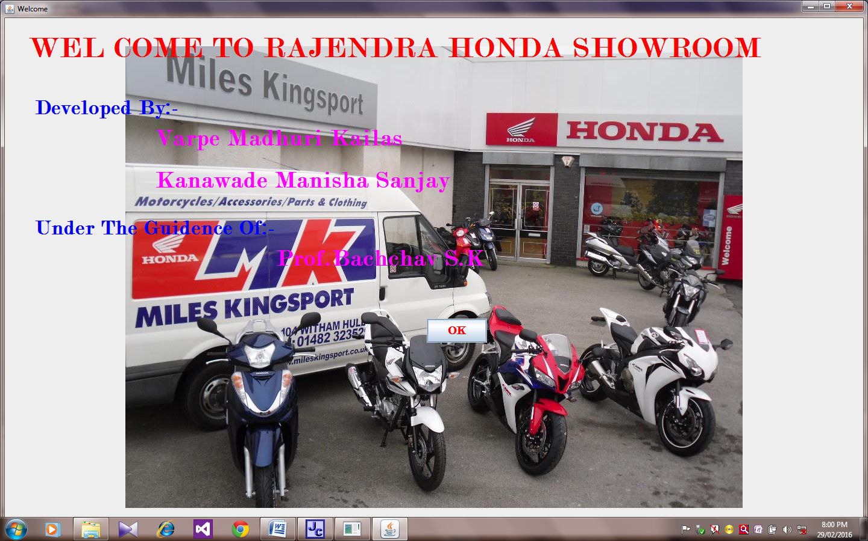

**WELCOME FORM:-**

**Login Form:-**

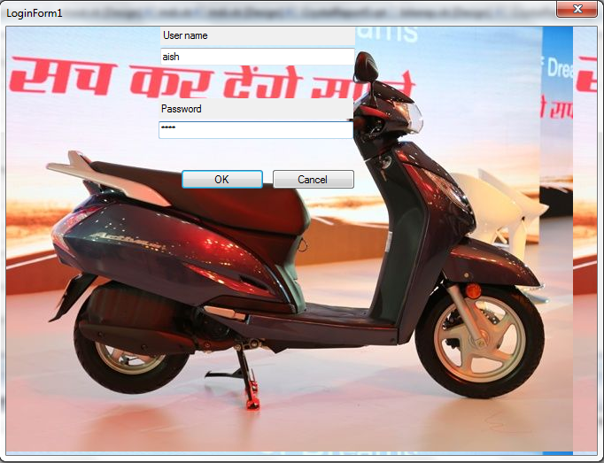

**MDI FORM:-**

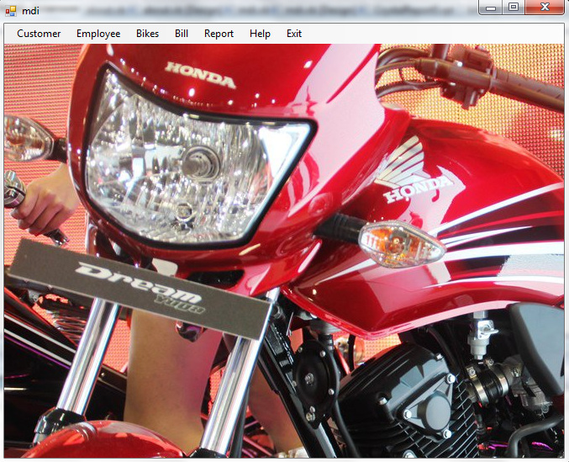

**CUSTOMER FORM:-**

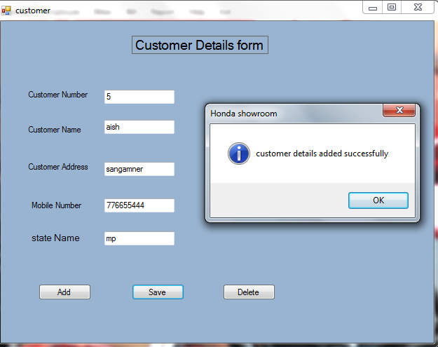

**EMPLOYEE:-**

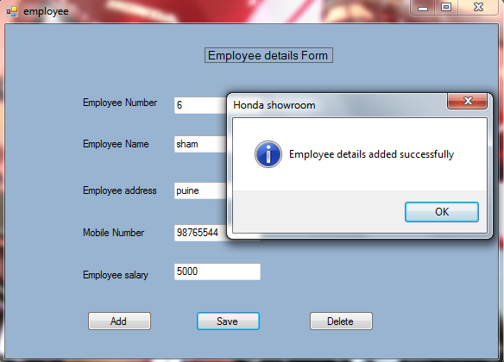

**BIKES FORM:-**

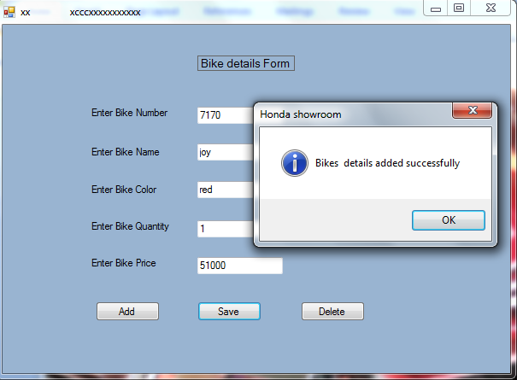

**BILL FORM:-**

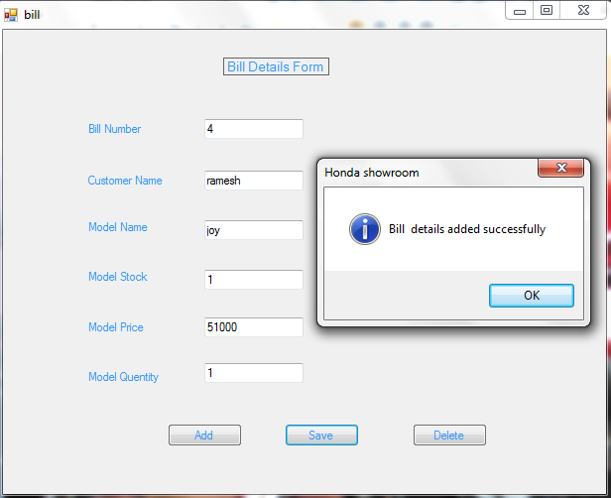

**ABOUT FORM:-**

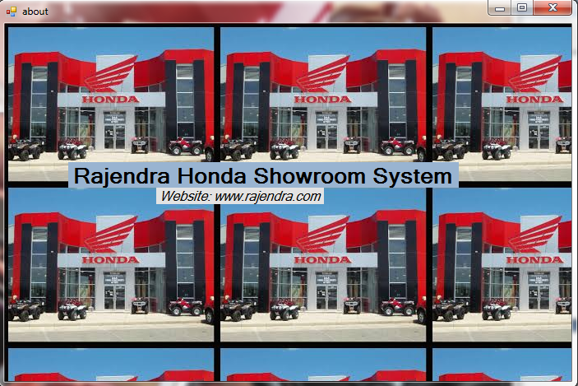

**CUSTOMER REPORT:-**

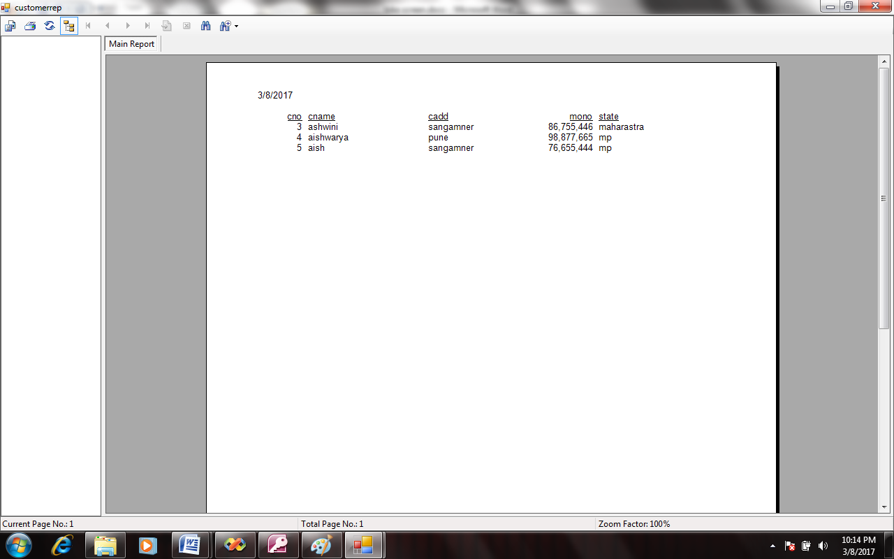

**EMPLOYEE REPORT:-**

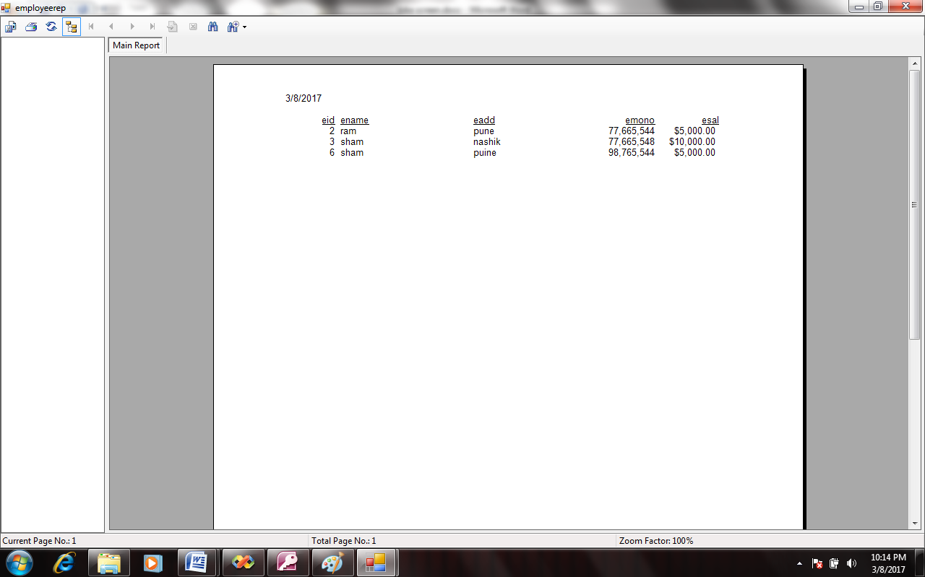

**BIKES REPORT:-**

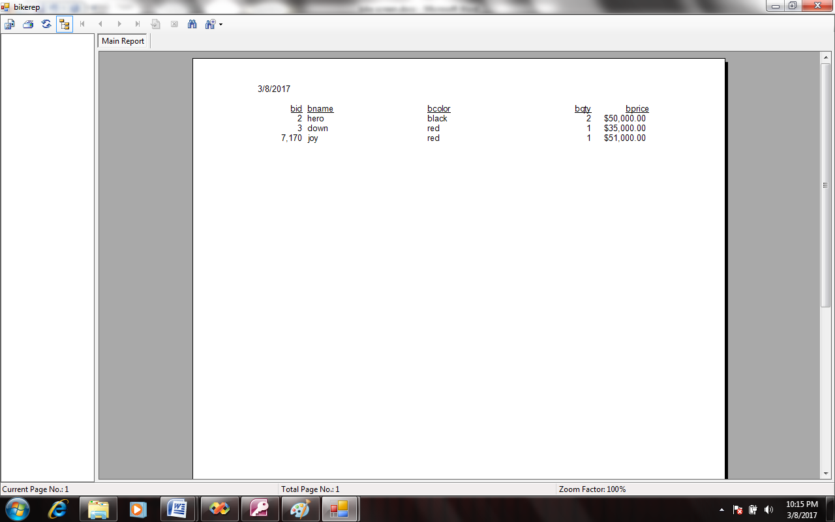

**BILL REPORT:-**

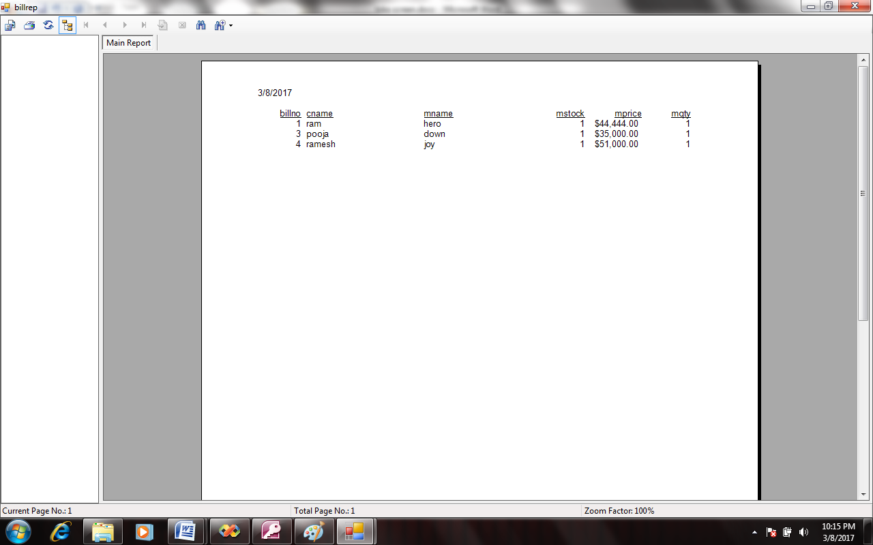

**Advantages:-**

* Reduction in time &money.
* System is synchronizing with system.
* Accurate result is obtained.
* Avoid mistake.
* very quick report generation.
* More security & safely for data.
* very easy to use.

**LIMITATIONS:-**

* Need skilled person to handle it.

Possibility of errors occurring during run time is more.

* Manual mistake can lead to hazards, as computer does not have

It’s own brain.

* The most important limitation of the existing system is its Manual system.

**BIBLIOGRAPHY:-**

Before and at the time of developing the project following books are feared which gear us seem important guidelines for designing and developing the project and project reports.

**Reference Book’s :-**

* Database System Concept–Sudarshan&Silberschath&korth
* Software Engineering

**Web Site’s :-**

[www.google.co.in](http://www.google.co.in)

<http://www.wikipedia.org>